ISSACK WAITHAKA
cs-sa07-24085

INTRO TO OFFENSIVE SECURITY
- Offensive security is breaking into computer systems, exploiting software bugs and finding loopholes in order to gain unauthorized access to them.
- Defensive security is the protecting an organization’s network and computer systems by analyzing any potential digital ganger.

Questions
1.
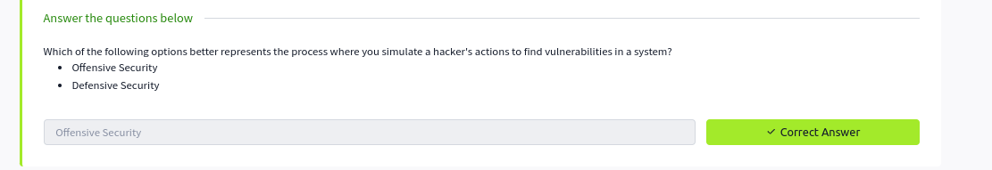
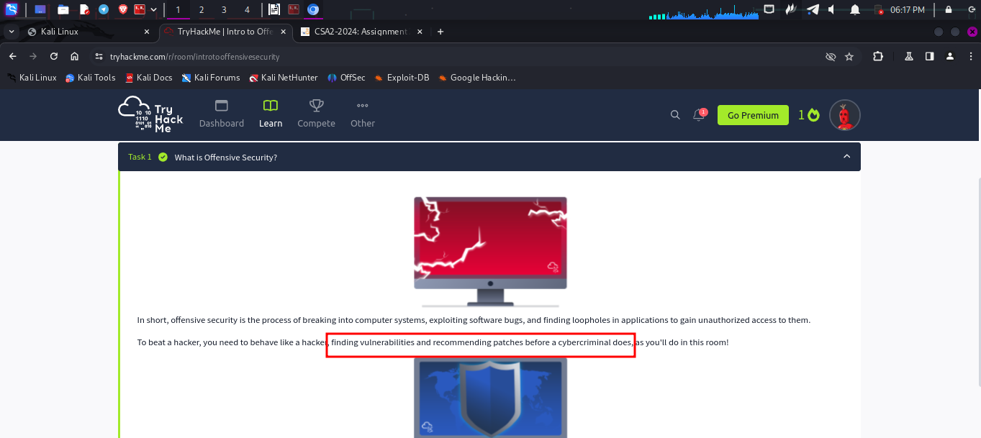
Hacking your first machine
- The first thing was to start the machine
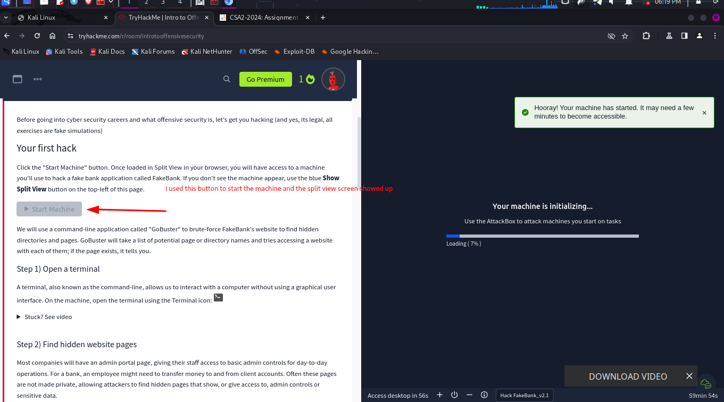
-
-The second thing was to start the terminal
- The next step was finding hidden websites. We used gobuster command to find the hidden pages
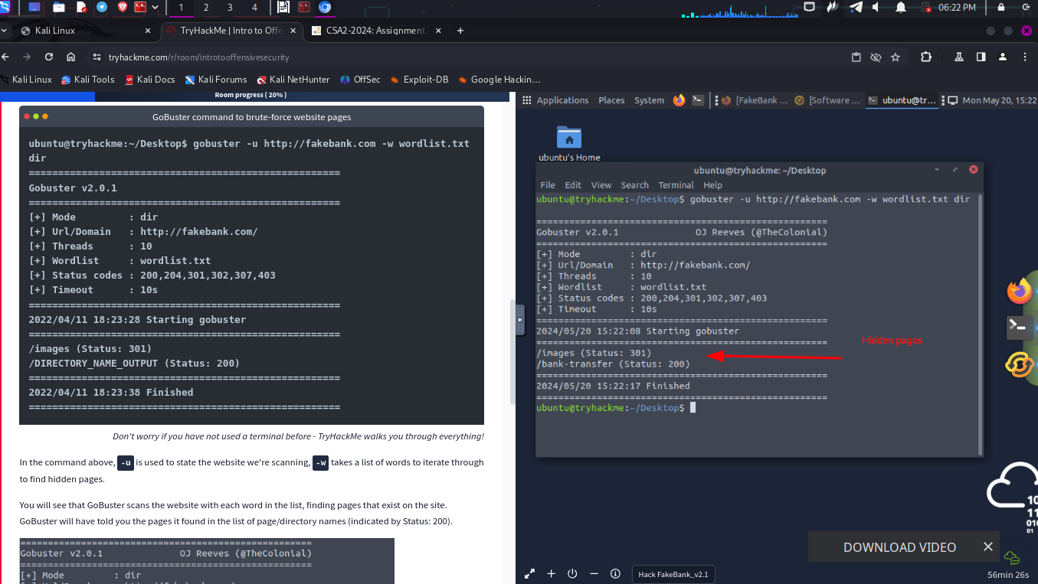
- the last step was to transferred $2000 from the bank account 2276 to my account
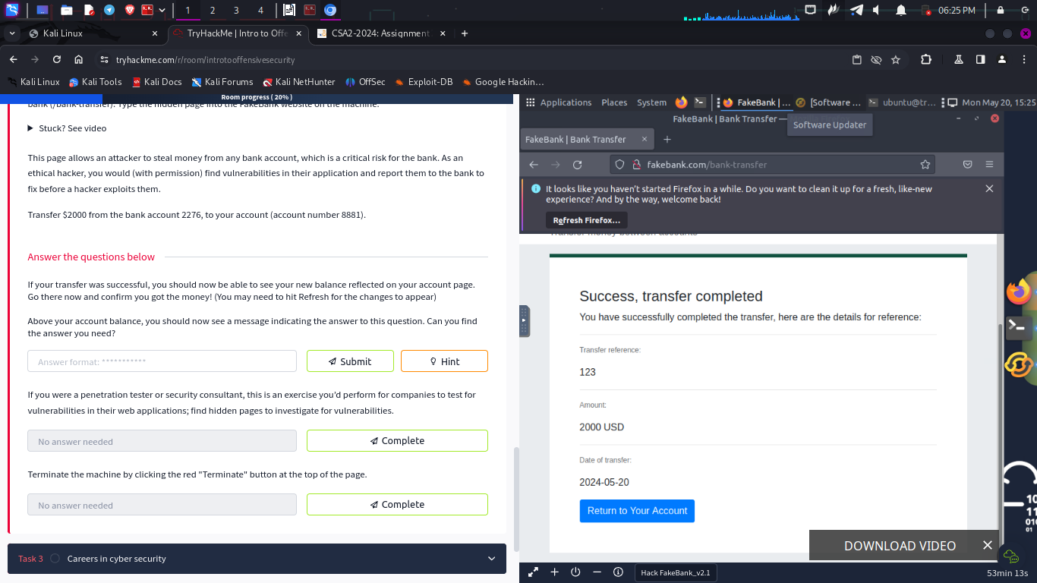
Questions
1.
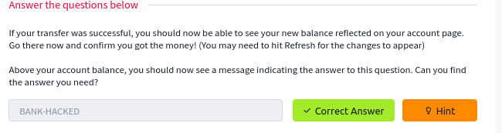
When I went back to home page I found the flag
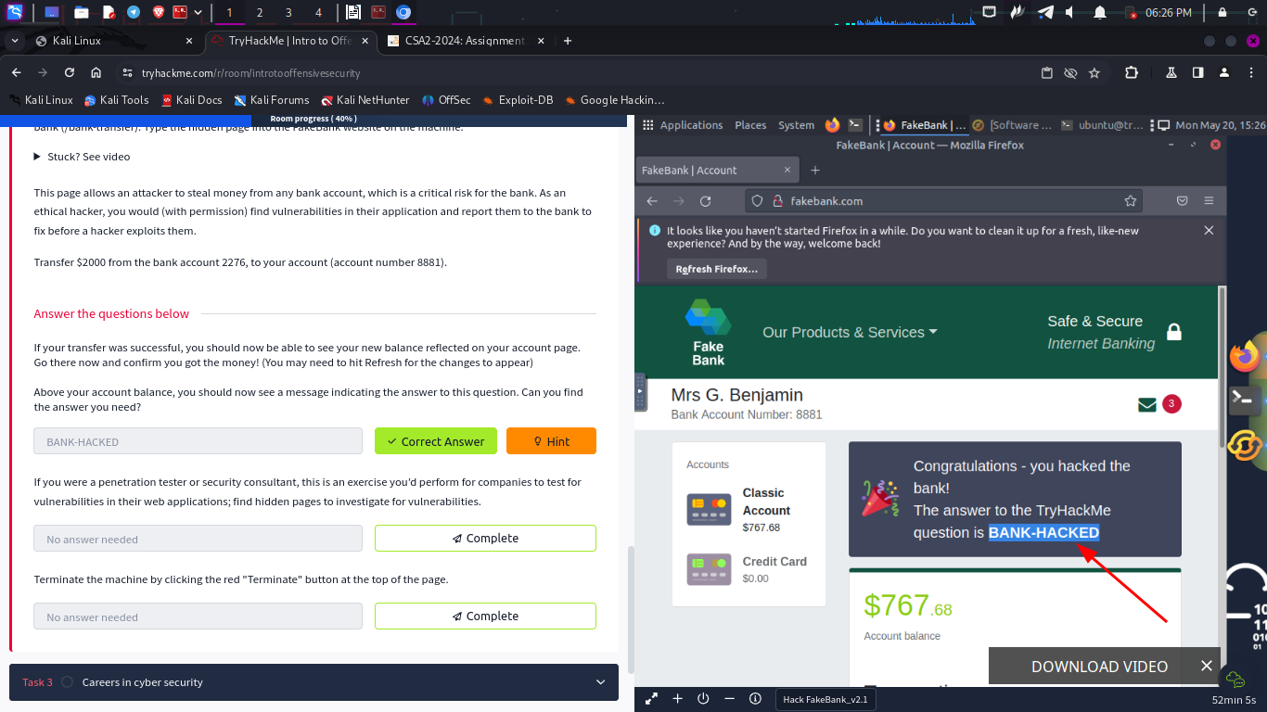
Careers in cyber security
- I learnt that there are various fields in security.
- I read peoples testimonies and how they started their careers in cyber security



WEB APPLICATION SECURITY
Introduction
- A web application is a program that is stored on a remote server and is accessible over the internet through a browser like chrome,brave etc.
Questions
1.

Web Application Security Risks
- The attacker may try to discover your password when you try to login
- An attacker may try to breach system by adding malicious codes to the search bar
- The attacker would check payment details sent in clear text or using weak encryption
- Identification is the ability to identify a user while authentication is proving that the user is whom they claim to be

Questions
1.
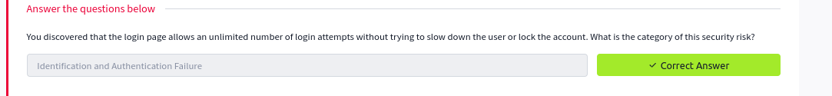
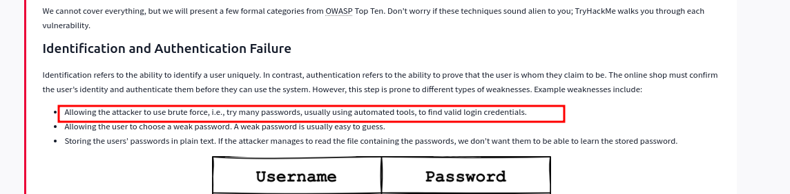
2.

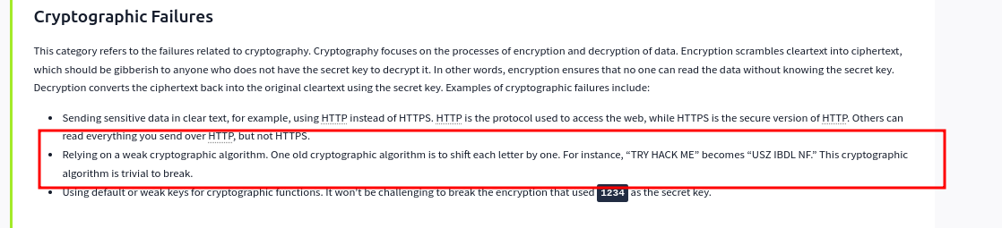
Practical Example of Web Application Security
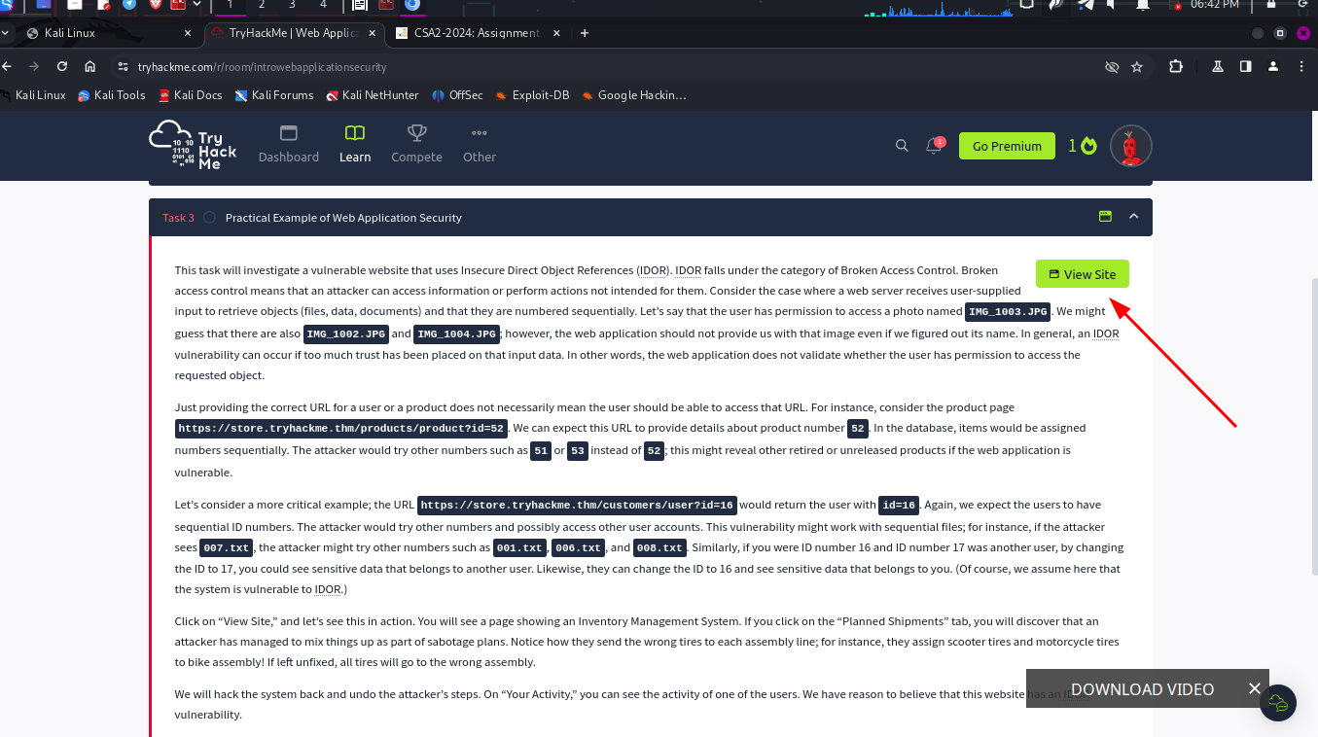
-
- We start by clicking the view site button
- We used broken access to alter with the URL and manage to get the id of the employee whose user’s account was used to make malicious changes.
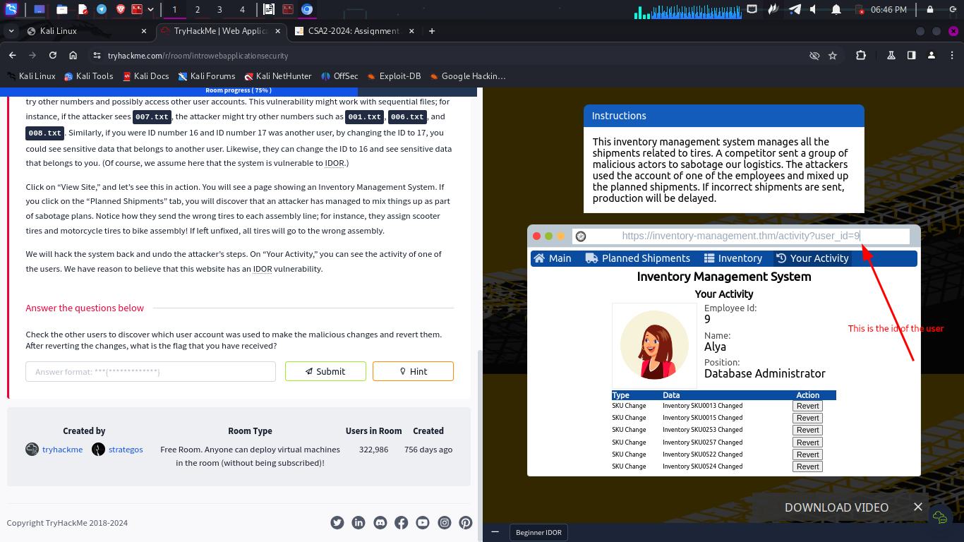
I reverted the changes and got the flag
questions
1.

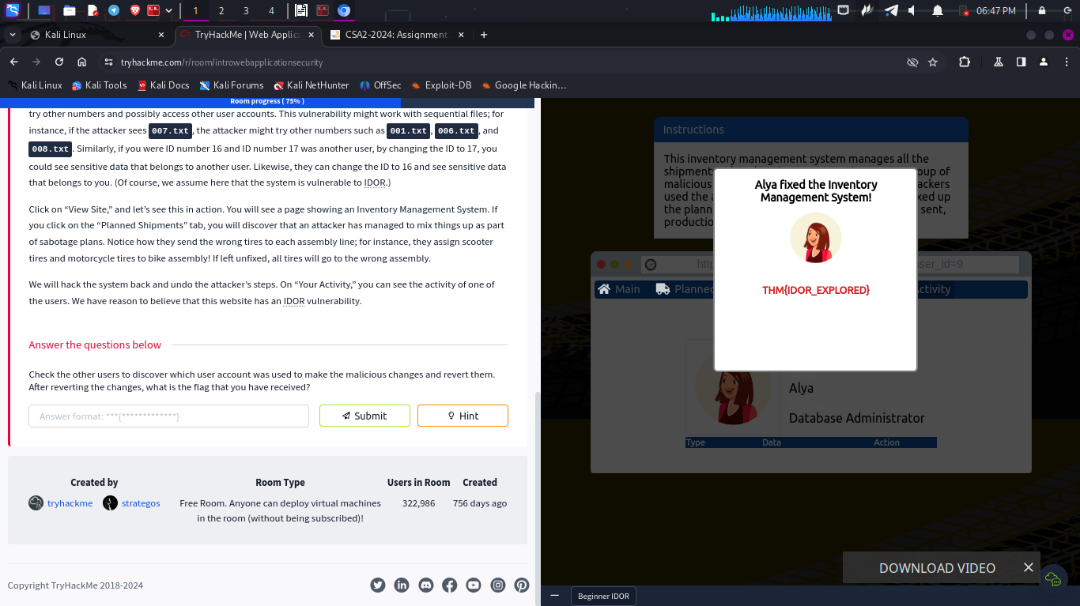

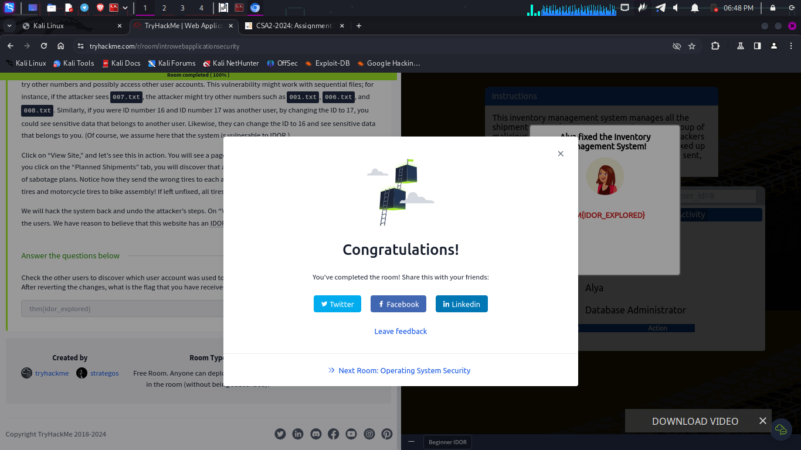

INTRO TO DIGITAL FORENSICS
Introduction
- This is identifying, analyzing. Processing and reporting data stored electronically
- It was born due to the usage and spread of digital systems like computers and smartphone

Questions
1.

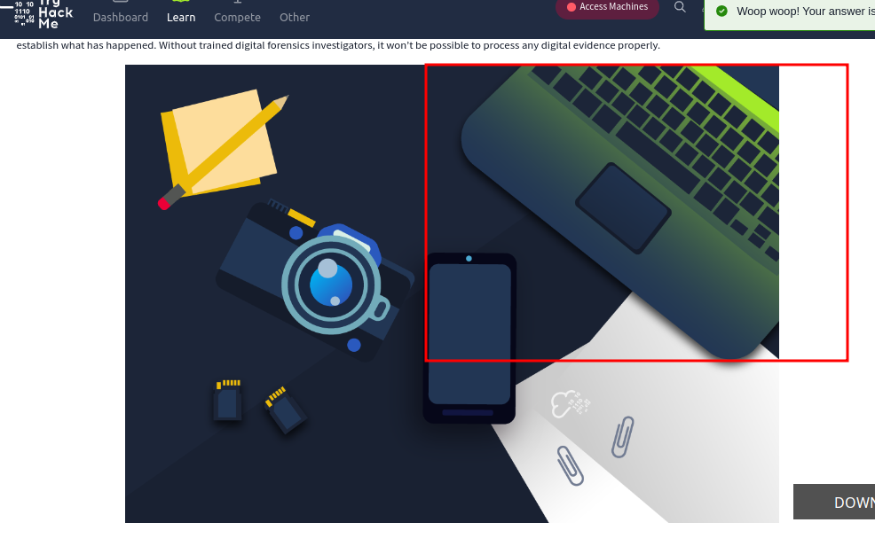

Digital Forensics Process
When you arrive at the scene you:
- Acquire evidence – collecting digital devices
- Establish chain of custody – fill out forms
- Place evidence in a safe container
- Transport evidence to the lab

- At the lab:
- Retrieve digital evidence from the container
- Create a forensic copy
- Return digital evidence into the container
- Start processing the copy on the workstation

Questions
1.
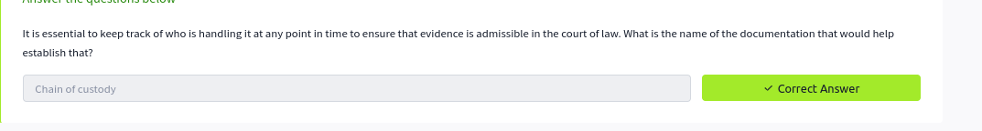
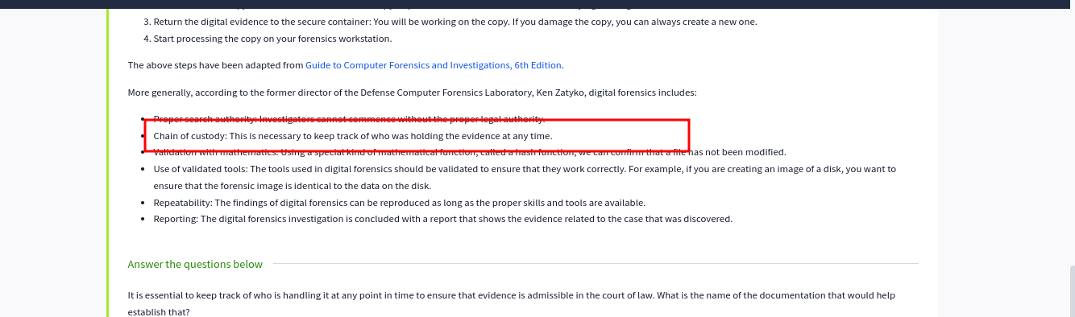
Practical Example of Digital Forensics
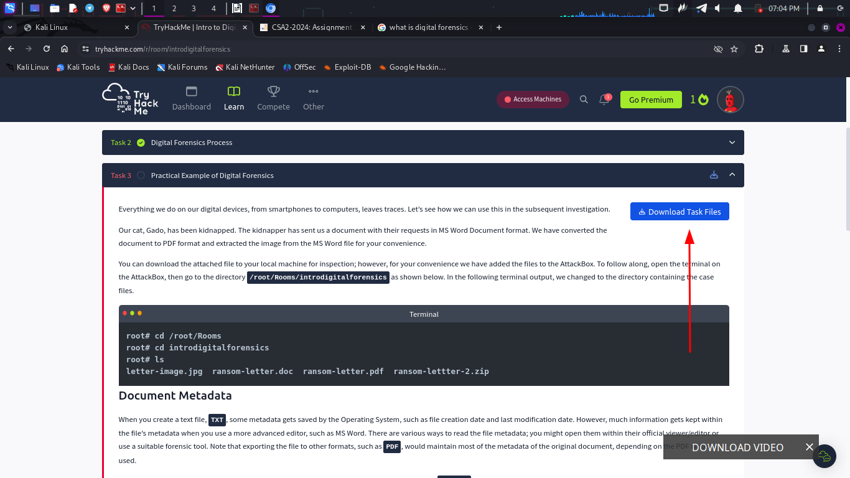
- I download these files in my local machine
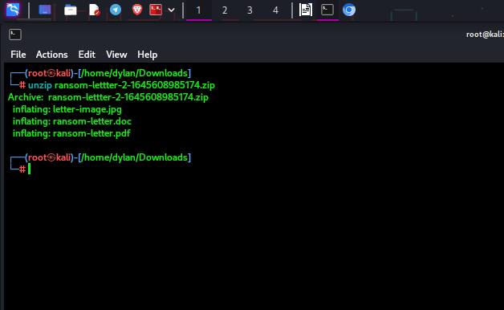
- I unzipped the file and got three other files
- I used pdfinfo tool to find the metadata of the inflating-letter.pdf and here are the results
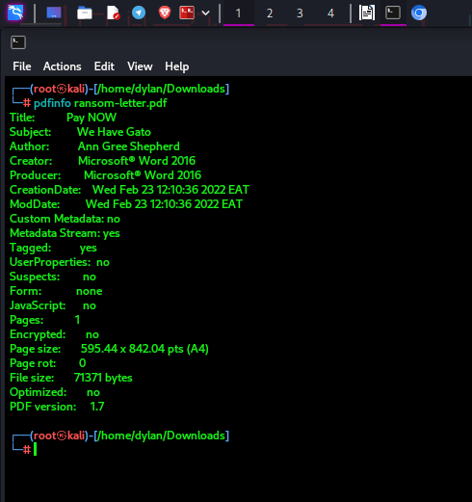
Question
1.
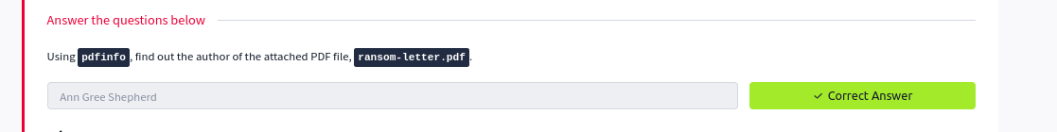
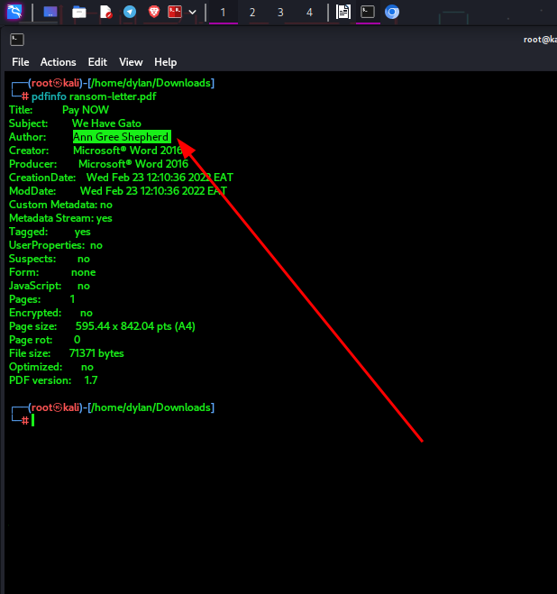

questions
1.

- I used the exiftool tool to get more information about the image
- To get the location I took the GPS latitude and longitude from the results
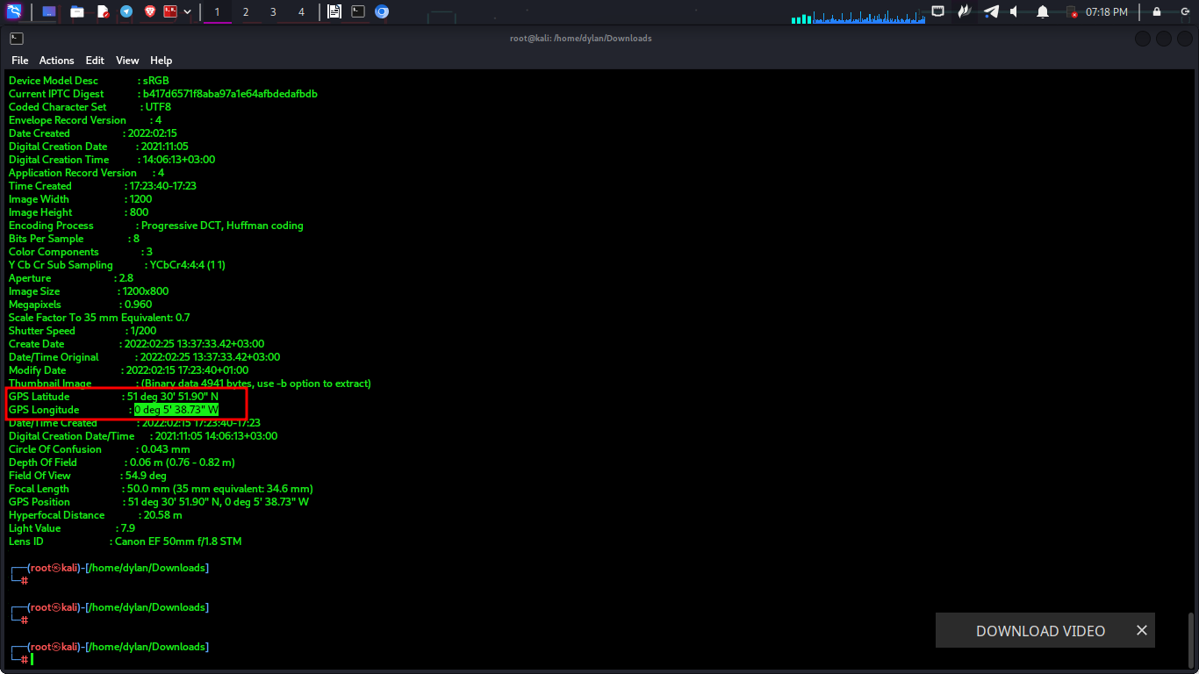
and paste them into google bing to get the exact location
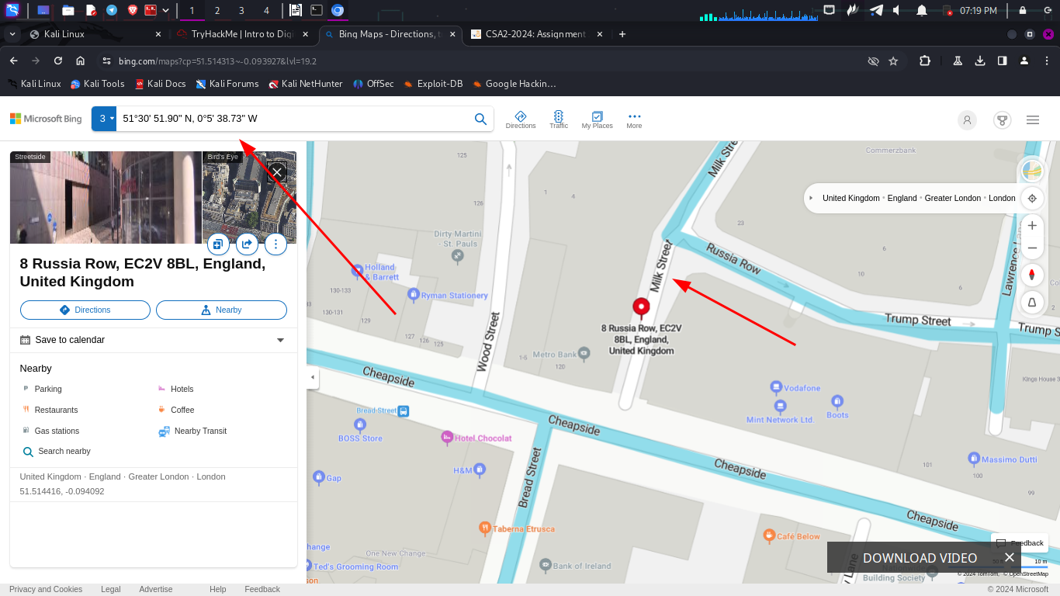
and got the location where the image was taken

2.
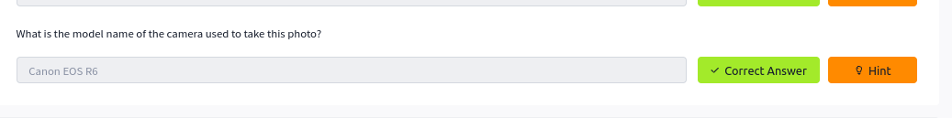
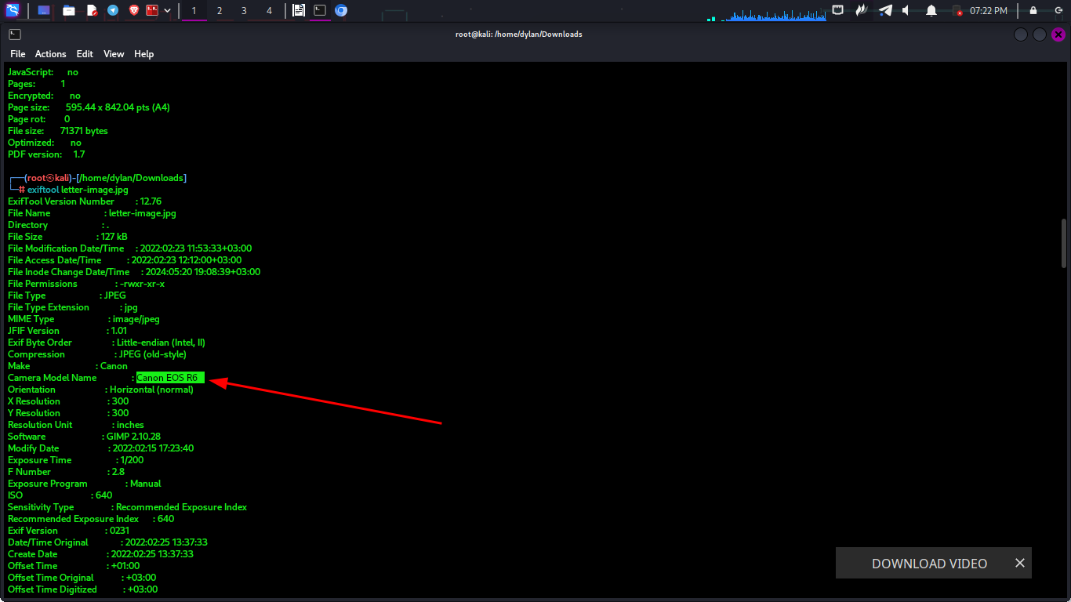

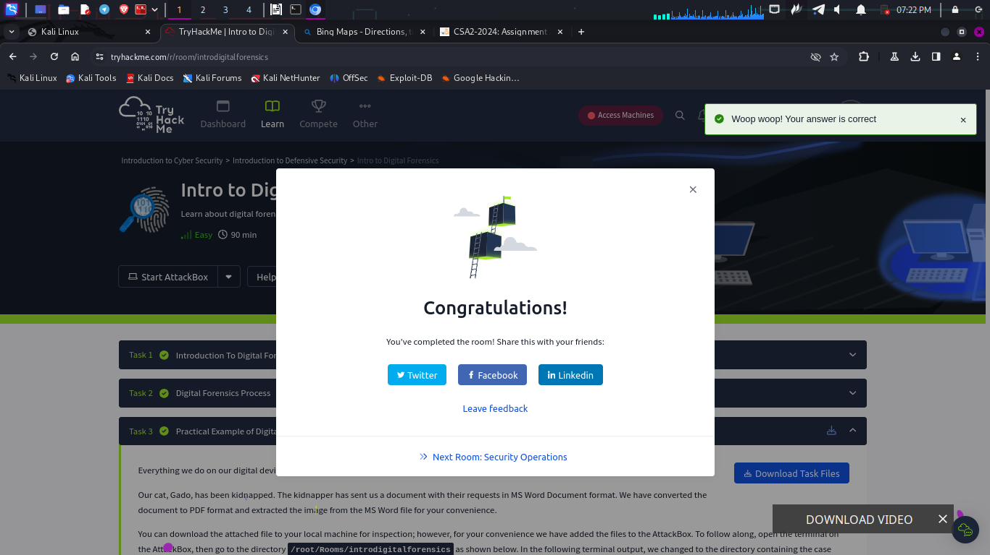

Conclusion
- In this modules I learn the basic that I need to start my cyber security journey. I have learnt the different cyber security careers. I now know the steps one takes to conduct digital forensics and some of the tools used.

